**AIM:**

**DATE: 12-Feb-2021**

**Roll no.:18BCE186**

**Name: Prem Desai**

**Course: LAMP TECHNOLOGY**

**2CSDE69**

**Practical No.:01**

**(A) Configure and understanding of LAMP and XAMPP server**

**(B) Design your personal profile web page, which contains all your personal, academic, co-curricular information, using basic concept of HTML, CSS and JavaScript.**

**Methodology followed:**

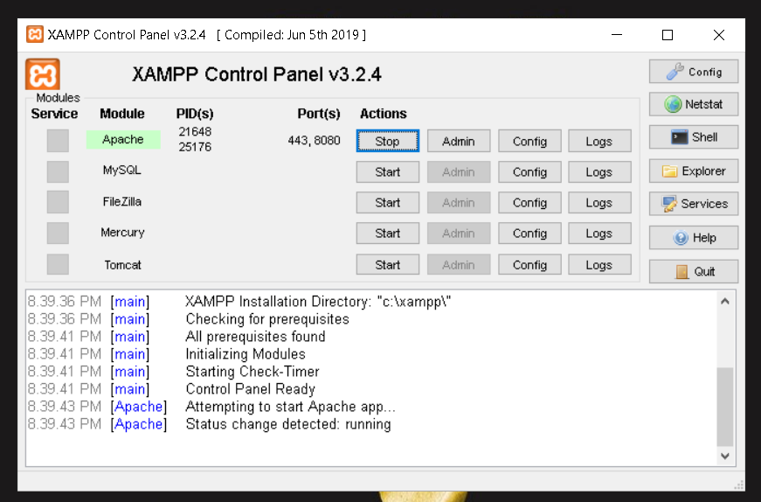

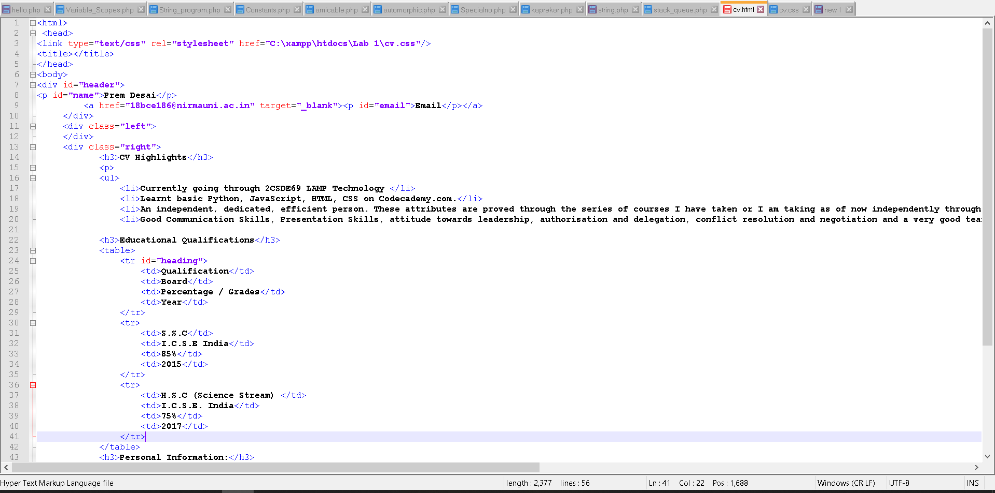

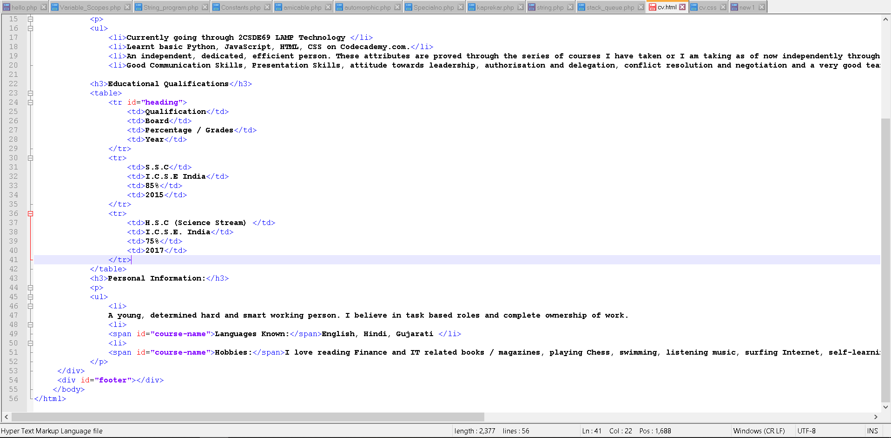

**Input:**

**For this particular practical, no inputs were required.**

**Output:**

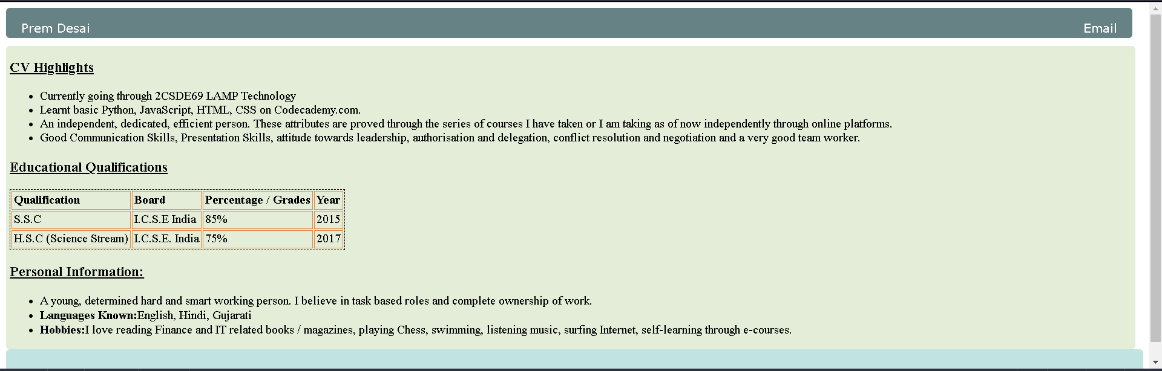

**Conclusion:**

**In this practical XAMPP was installed and explored also webserver was configured.**

**The configured server was then used as local host to run the above html/CSS code.**

**Signature of teacher :**